Link to the deployed page

- ducs1.herokuapp.com

or

- ducs.herokuapp.com

• Credit people/organizations you borrowed code from or APIs you used - e.g., Bootstrap,

- Bootstrap: http://getbootstrap.com/

- Codecademy: https://www.codecademy.com/

- W3 schools: https://www.w3schools.com/

• List of all project features implemented and associated screenshots

Total List of implemented features:

* + User Authentication with easy sign-in
  + Data collection and calculations
    - Metric and Imperial
    - Volume and Depth
    - Zipcode or County
    - Optional notes
  + Email results to user
  + Results are informative
  + Storage of results in database
  + Presentation of database to admin
    - Data can be sorted and filtered
  + View of all calculations can be exported to csv
  + A delete button and a delete all button
  + Can see all measurements and organize by year and county
  + A welcome page
  + A how-to page for using the app and how to perform the calculation

-Home Page

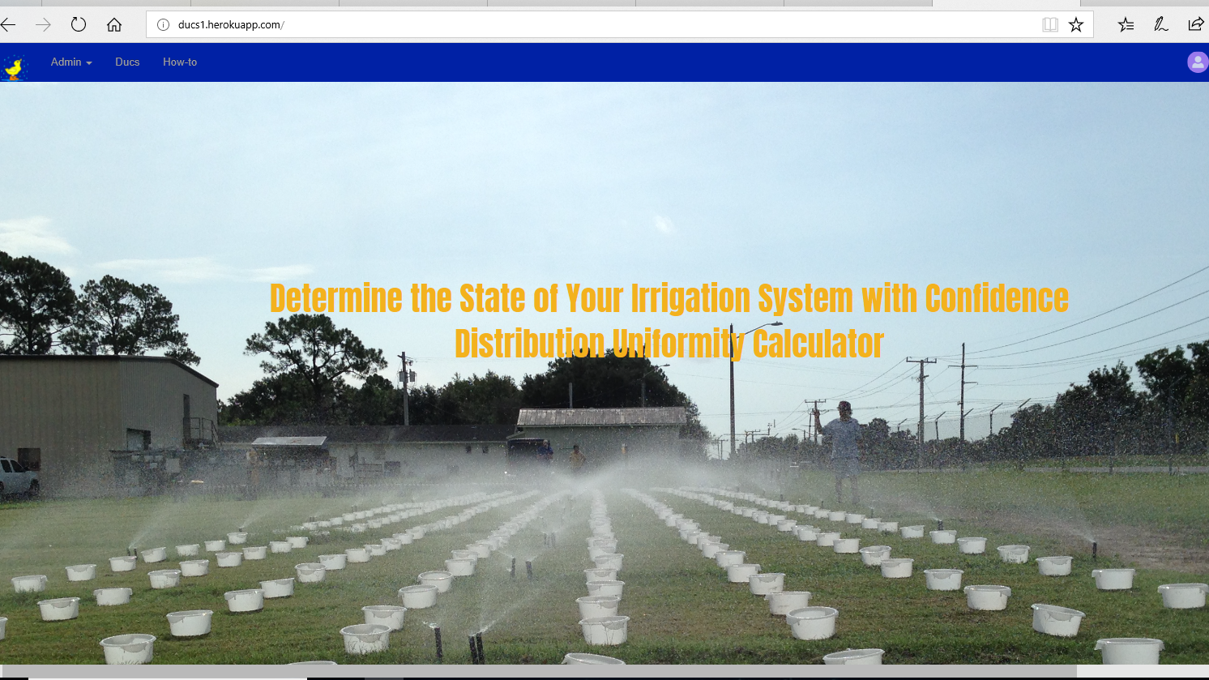

- Sign Up:

Email

User Name

Password

- Sign In:

User and Admin

Forgot Password

- Sign Out

- Data Collecting

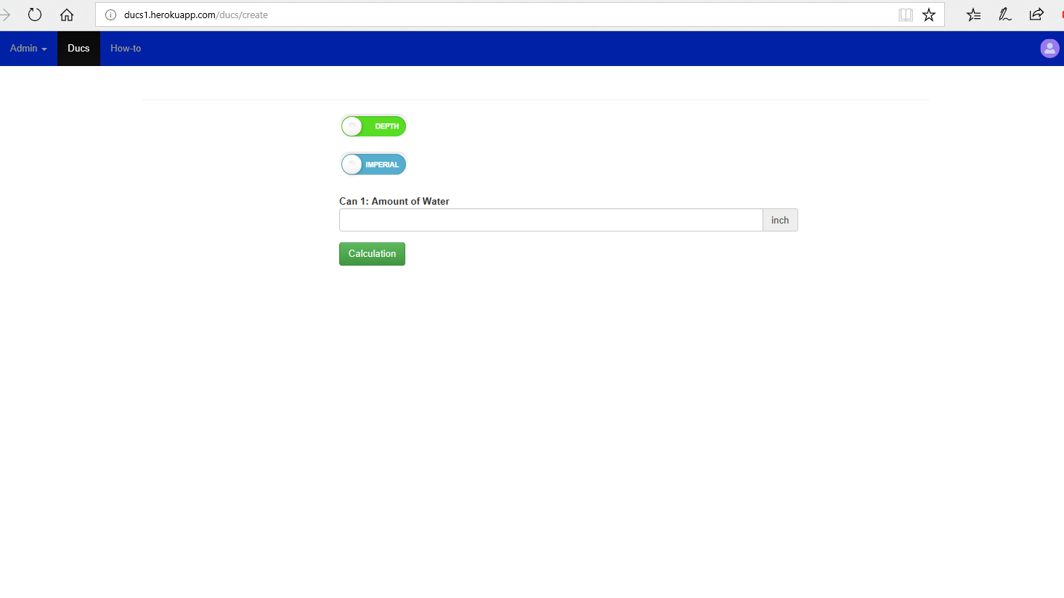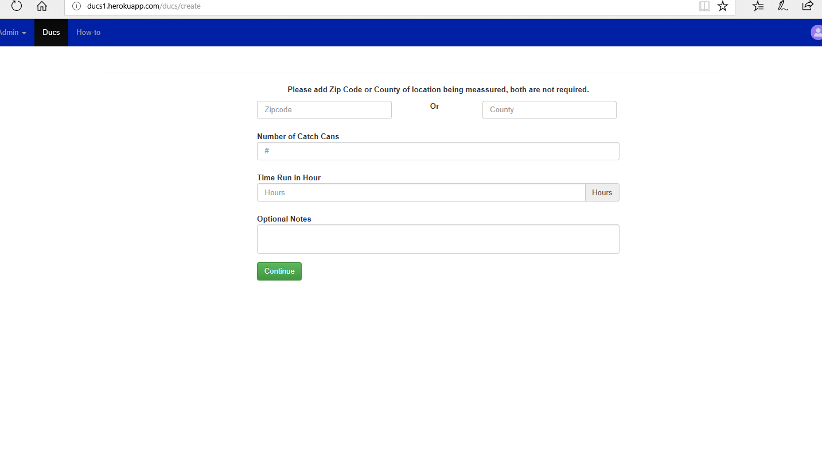

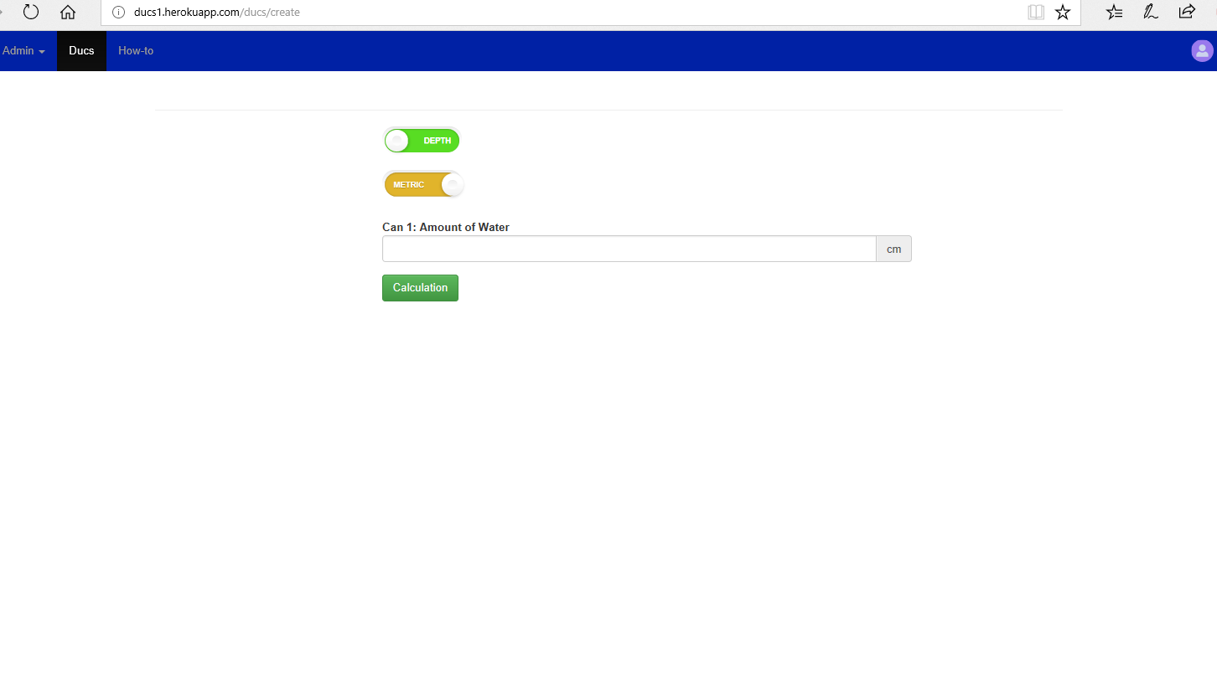

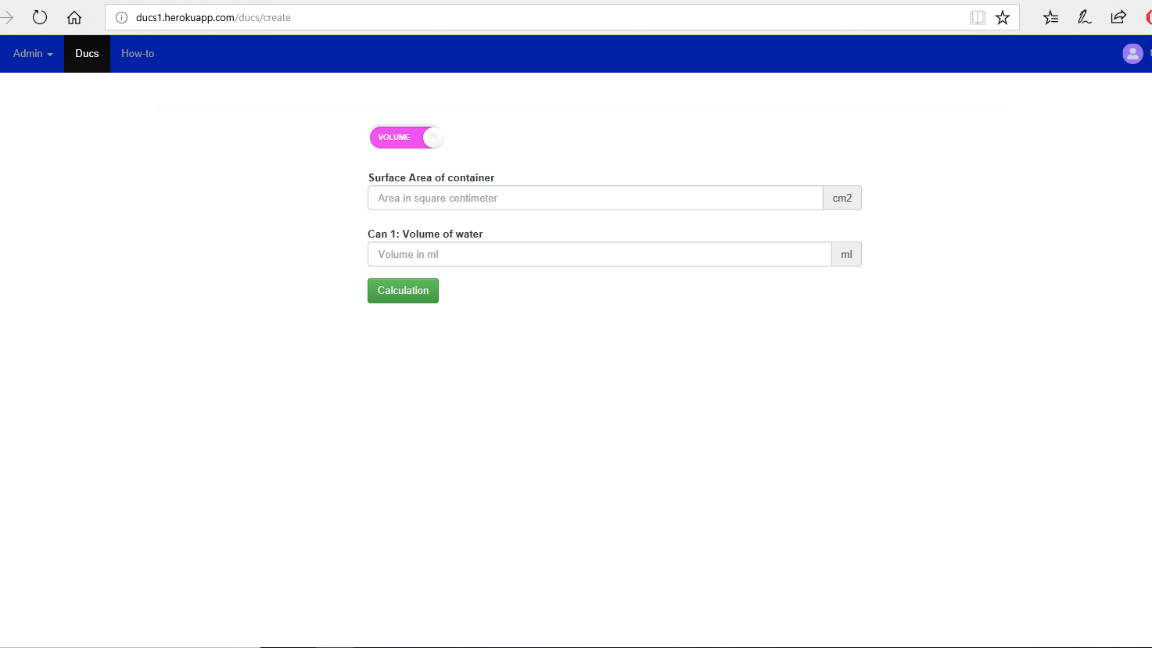

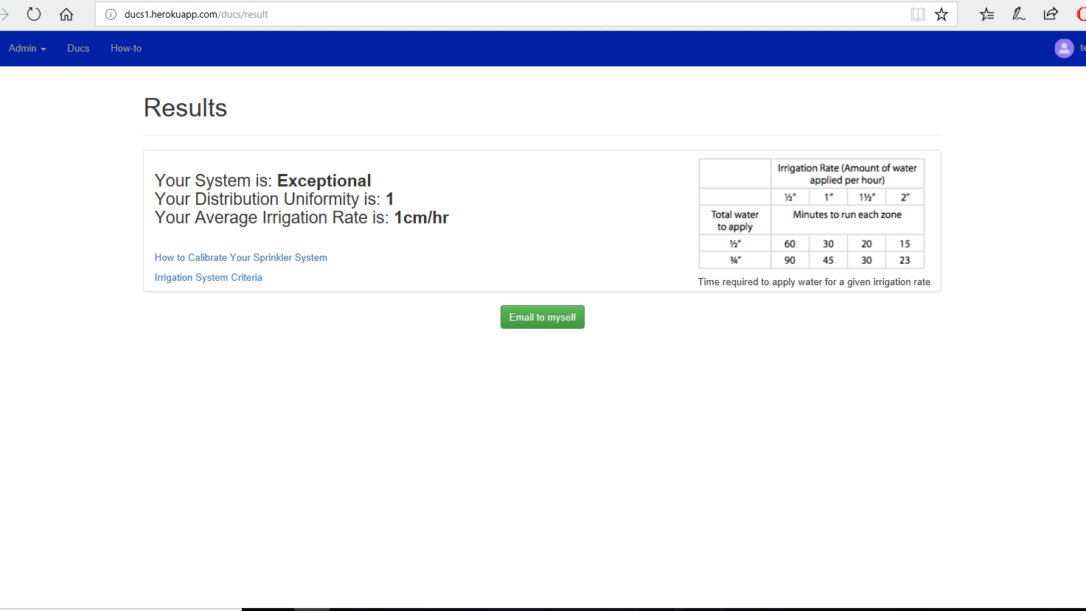

- Calculations of Data Collected:

Results:

Email to Yourself

Links to Additional Information:

http://manatee.ifas.ufl.edu/lawn_and_garden/master-gardener/gardening-manatee-style/c/calibrating-your-sprinkler-system.pdf

https://floridawaterstar.com/technicalmanual/irrigation/uniformity.html

- User page:

Edit Profile

Edit Profile Pic

Change Password

Data Collection:

Zipcode or County

Number of Catch Cans

Time Run

Optional Notes

Amount of Water Collected for Each Catch Can

Different Measurements for Collecting Data:

Depth or Volume

Imperial or Metric

-Admin page:

Same Features as Users for Inputting Data

List of Data Inputted by Users:

Filter Data

Delete Data

View More on Data That is Too Long

Delete All Data

Export data to csv

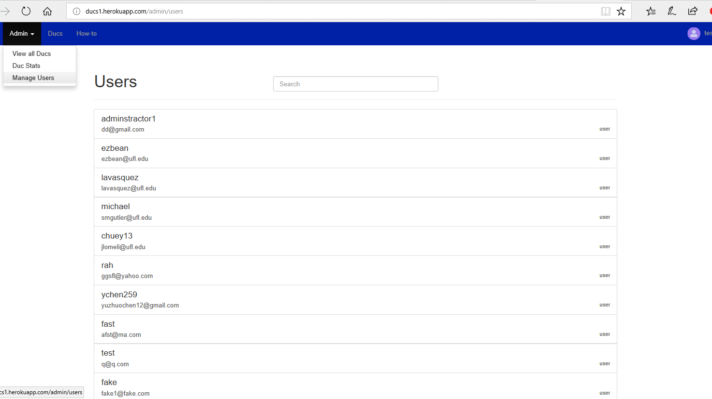

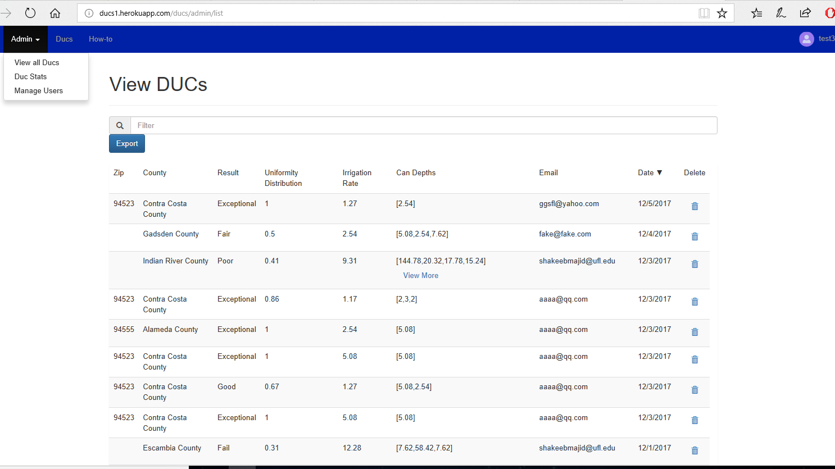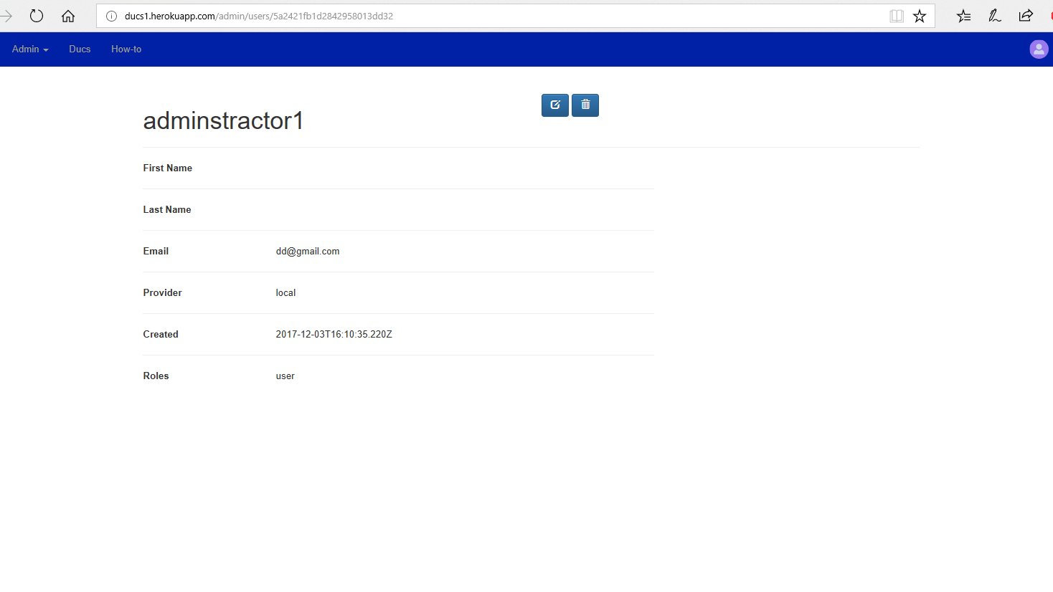

Stats of Data Collected by Year With the Number of Measurements from Each County:

Total Number of Stats From Each County

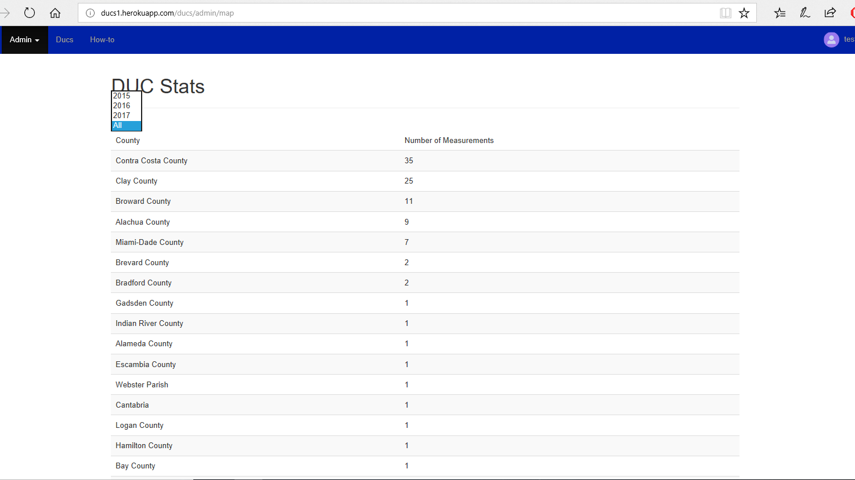

User Management:

Edit User

Remove User

Change User Role

Search Users

- "How-to":

How to Use the App Instructions

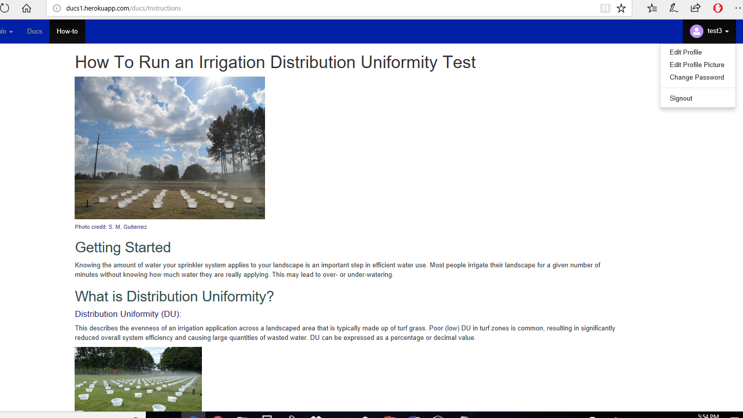

- Logo For the Department That Redirects to UF IFAS (Institute of Food and Agricultural Sciences) Website When Clicked

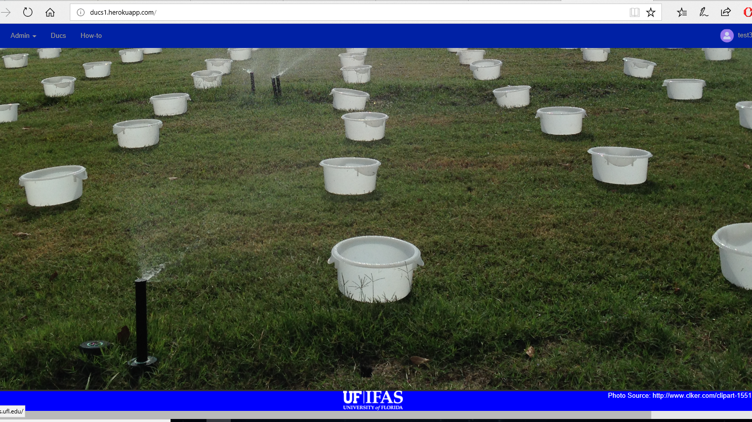

-Duc Logo in Top Left That Redirects You to the Home Page

• include landing or home page

- ducs1.herokuapp.com

• Instructions for how to run the project locally

- In the terminal make sure you are in the Mean folder

- Type node server.js

- Wait for the green words to pop-up in the terminal

- Go to any browser and type localhost:3000/

• How to update database and server connections

-set the environment variable `MONGOLAB_URI` to your mongoDB connection string or replace the string containing `mongodb://` on line 7 of `config/env/development.js' with your connection string

Helpful link: <https://www.twilio.com/blog/2017/01/how-to-set-environment-variables.html>